E-invoice API and registration Testing in CEM1.0 Production

A.E-invoice API test in CEM1.0:

1.loing to EC stie

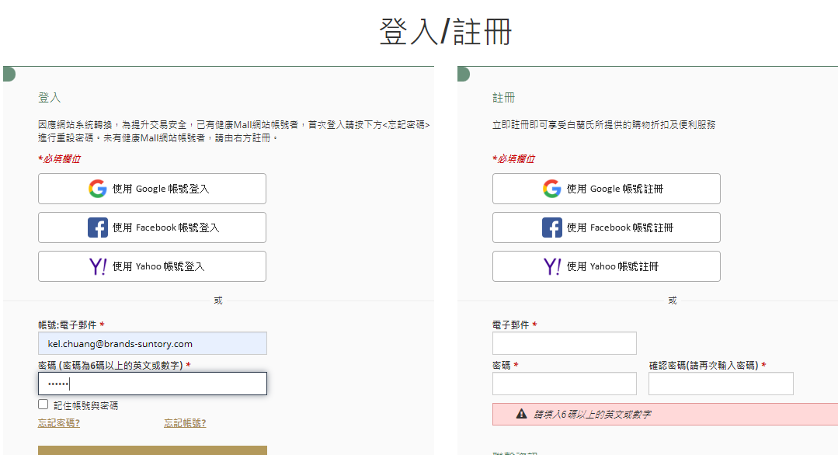

2.go to shopping cart with billing page

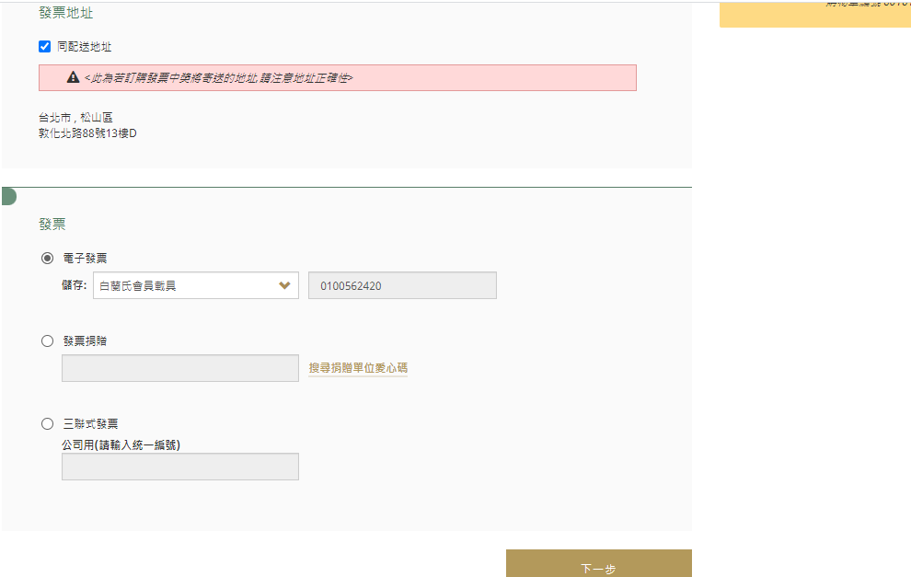

3.choice mobile Vehicle

4. If API is on, when you input Vehicle number as “/7.NNA44”, then click next step.

The system will show error message. “Please input mobile mobile Vehicle value”.

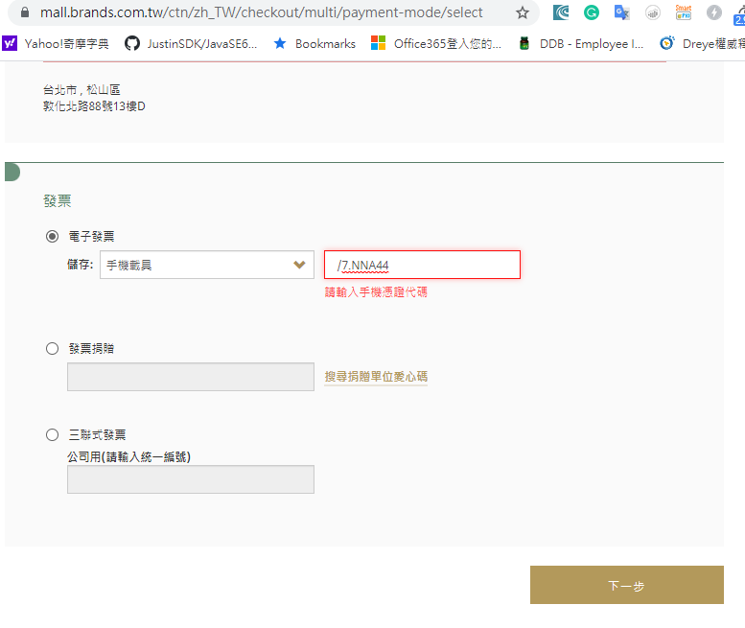

5.if you put the correct mobile Vehicle number as “/7.NNA4Q”, then click next.

The system will go to next page. The Einvoice have call API function.

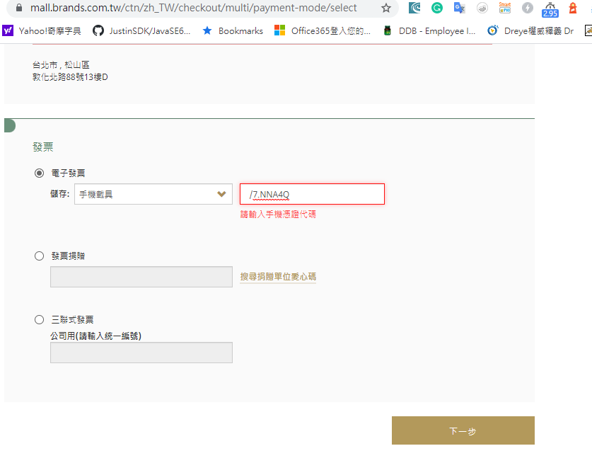

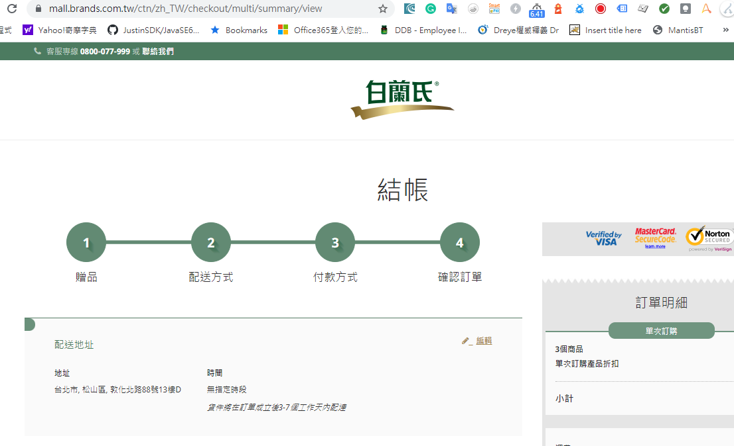

B.E-invoice registration test in CEM1.0:

1.loing to EC stie



2.go to customer service center in customer service.

3.go to relation E-invoice.

4.go to the link in the word.

5.system will go to government page and the page have “two” button.

(If appear one button, it mean registration fail in my site)

It mean registration go to government success, and the rest step is below government.



(If appear one button, it mean registration fail in my site)

